**DAILY ONLINE ACTIVITIES SUMMARY**

|  |  |  |  |
| --- | --- | --- | --- |
| **Date:** | 13/07/2020 | **Name:** | Krishnitha |
| **Sem & Sec** | 4th sem, A Section | **USN:** | 4AL18CS039 |
| **Online Test Summary** | | | |
| **Subject** | Microcontroller and Embedded Systems | | |
| **Max. Marks** | 30 | **Score** | NA |
| **Certification Course Summary** | | | |
| **Course** | Introduction to HTML5 | | |
| **Certificate Provider** | Coursera | **Duration:** | 3 hrs |
| **Coding Challenges** | | | |
| **Problem Statement:**  Write a Java Program to find the duplicate characters in a string. | | | |
| **Status:** Executed | | | |
| **Uploaded the report in GitHub** | | YES | |
| **If yes Repository name** | | <https://github.com/krishnitha/Java-coding> | |
| **Uploaded the report in slack** | | YES | |

**Descriptive Test:**

Today we had assessment on the subject Microcontroller and Embedded Systems. There were four questions of 10 marks each out of which we had to attempt three questions.

**Certification Course Details:**

Today I continued the course “INTRODUCTION TO HTML5” by Coursera. Today I learnt about The Document Object Model. I have completed week 2 portion of this course.

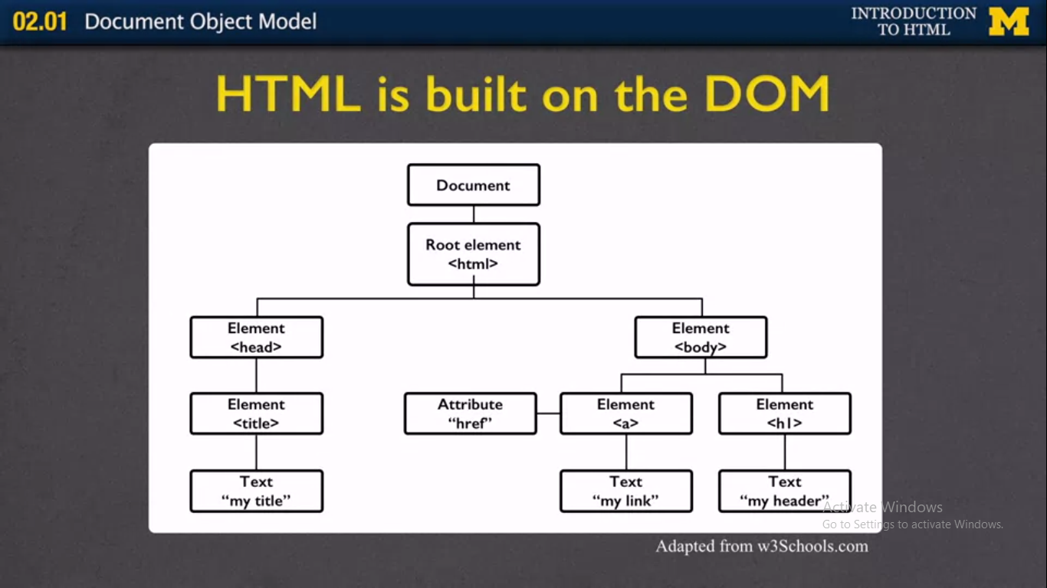

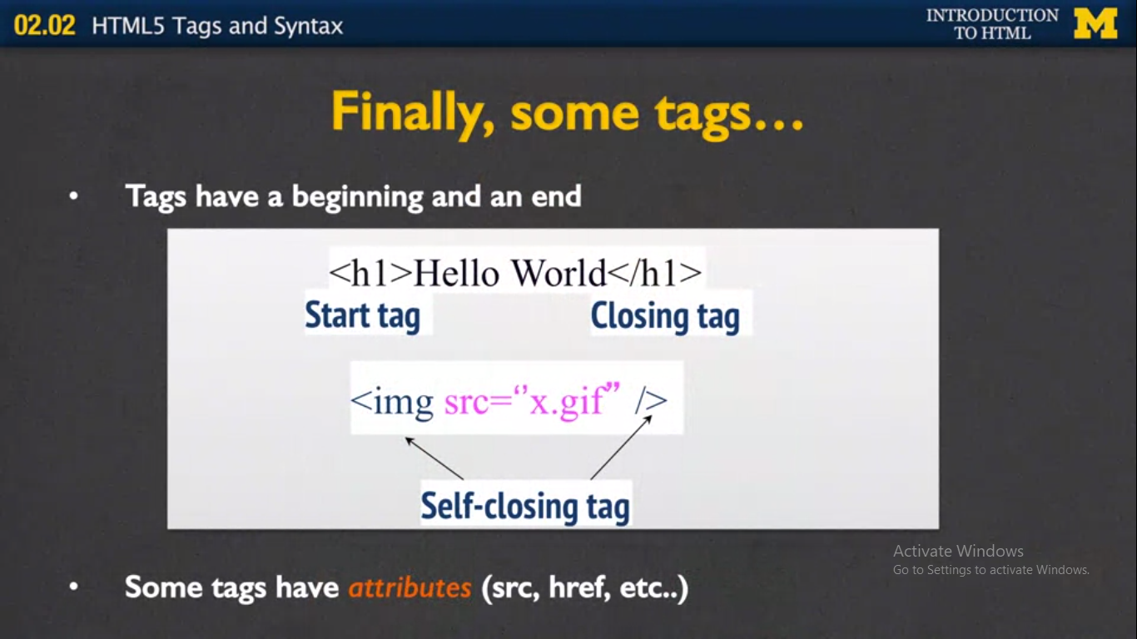

**Coding Challenges Details:**

**Problem:** Write a Java Program to find the duplicate characters in a string.

**Solution:** Uploaded it in GitHub

